EC4070: Data Structures and Algorithms

LAB 05

K.J.M.U.G.S. Eranda Jayasinghe

2021/E/075

SEMESTER 4

EC4070

01.11.2023

Q1.

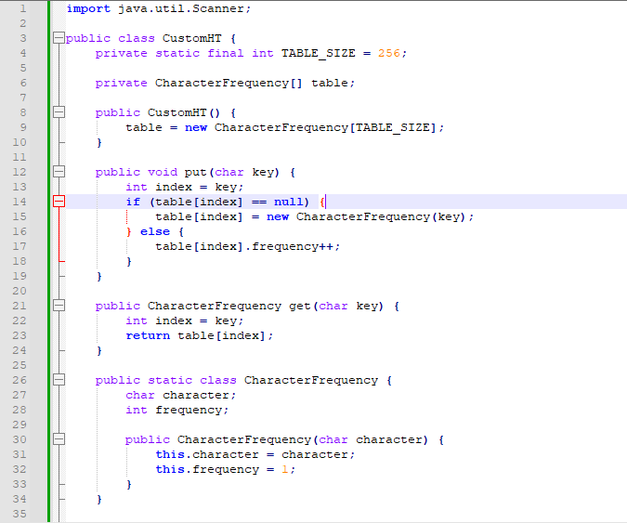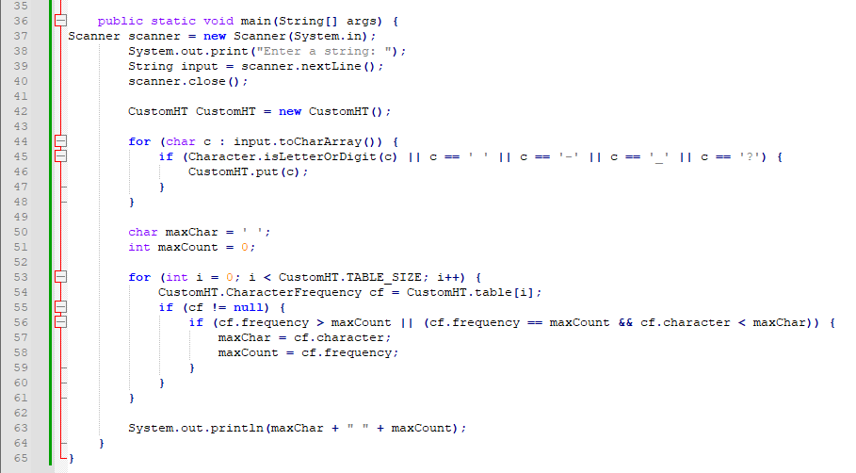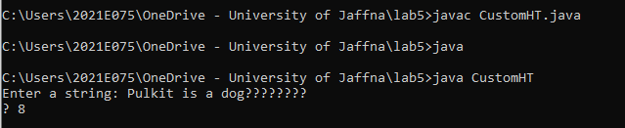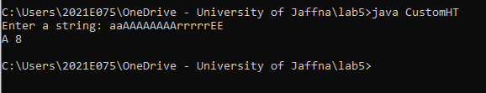

Q2.